This project is only for 1 company and 1 Chairman and Multiple- warehouse() and 1-Office

Modules:

1- Users Managemnet:

2- Product Managemnet:

3- Notification Managemnet:

4- Report Managemnet:

5- order Management:

6- Route Management:

7- Warehouse Management:

1- Users Managemnet:

5-actors(Accounts):

1- chairman

2-employee

3-rider

4-WAREHOUSE MANAGER

5-SHOPKEEPER

1- Chairman functions(2nd UC):

1-Login

2-Add employee

3-Add rider

4-Add WareHouse and (compulsory) assign Manager

5-Add product

6-CRUD(of every user and Product)

7-Communication of Reports(

1- Rider and Employee(private for shopkeeper)

2-Employee AND Chairman(private )

3- SHOPKEEPER AND employee(private to rider)

4- WM and employee(private to roder and shopkeeper)

)

8-Reports of Product (csv (profits(must) )

2- Employee(3rd UC):

1-Login

3-Add rider

4-Add WareHouse Manager

5-Add product

6-CRU(of some user and Product)

7-Communication of Reports(

1- Rider and Employee(private for shopkeeper)

2- Employee AND Chairman(private )

3- SHOPKEEPER AND employee(private to rider)

4- WM and employee(private to roder and shopkeeper)

)

8-Order record (area detail and product detail )

9-Shopkeeper RECORD(rating , )

3- Warehouse Manager(4rth UC):

1-Login

2-Add product(attribute check name with type bool)

3-RU(of some user and Product)

4-Communication of Reports(

1- WM and employee(private to roder and shopkeeper)

)

5-report of products

4-Rider(5th UC):

1-Login

2-order detail

3-Ratings

4- communication with employee and shopkeeper and WM

5-SHopkeeper(6th UC )

1-Login

2-order detail

3-order place

3-Ratings

4- communication with employee and rider

5-R(retrive of products)

2- Product Managemnet:

-CRUD(EMPLOYEE(execpt D) AND CHAIRMAN others only R execpt rider)

3- Notification And Email (Communication) Managemnet:

-

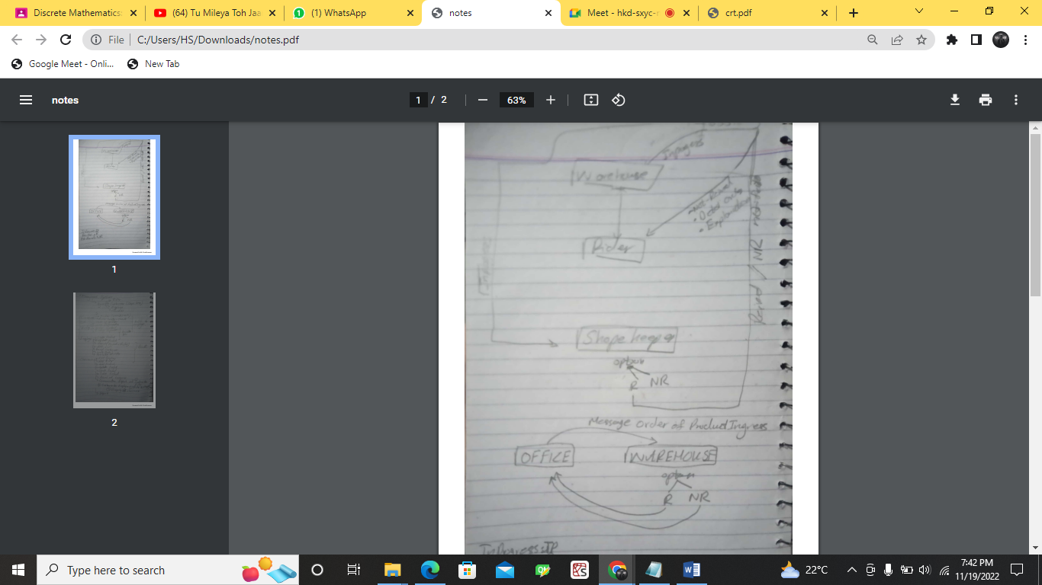

4- Report Managemnet:

5- order Management:

6- Route Management:

7- Warehouse Management:

8- Expenditure Management: